|  |
| --- |
|   John A. Walker College of Business**  **Appalachian State University** |

**CIS 3750 Sections 101, 102 & 103**

**Database Management**

**Exercise #1 – Create Table & Basic Aggregate Function**

## Query Exercise Detail

Use SQL and the tiny national community-based accommodation InstantStay database to run query on SSMS.

Make sure you use the database with your Last Name-First Name Initial.

It focuses on gathering the house owners and tenants together as a trusted platform. Hosts join to the system with their houses to be rented out. Similarly, guests join to the system to rent available houses. In addition, channels such as travel agencies, newspapers join InstantStay for connecting customers from different platforms.

**1/ Create a table name OWNER.**

**2/ Perform inserting values to the OWNER table.** [values are provided in the exercise assignment on AsULearn]

In the OWNER table, data for the house owners are collected with their personal information as shown in the following table:

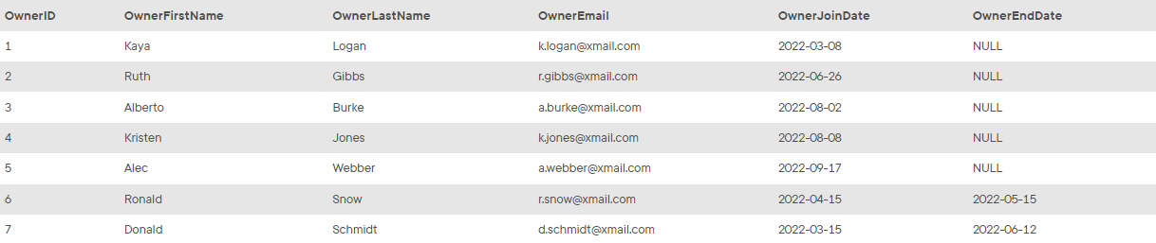

**3/ Create a table name HOUSE.**

**4/ Perform inserting values to the HOUSE table**. [values are provided in the exercise assignment on AsULearn]

In the HOUSE table, all houses in InstantStay are collected with detailed address and respective characteristics about the houses:

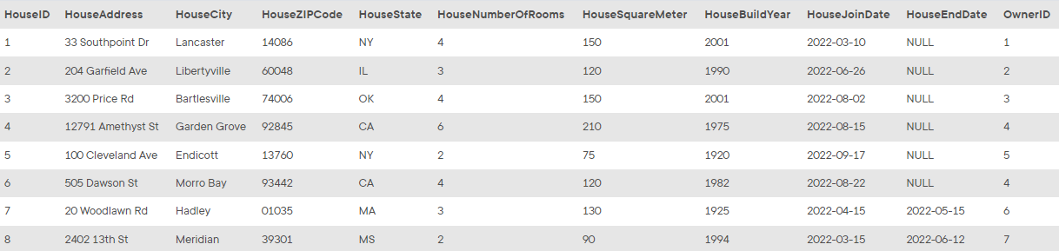

**5/ Create a table name GUEST.**

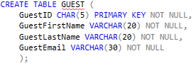

**6/ Perform inserting values to the GUEST table. [**values are provided in the exercise assignment on AsULearn]

Guests are the customers registered to the platform to access information, offers and stay at houses in InstantStay. Data of the guests are collected in the GUEST table:

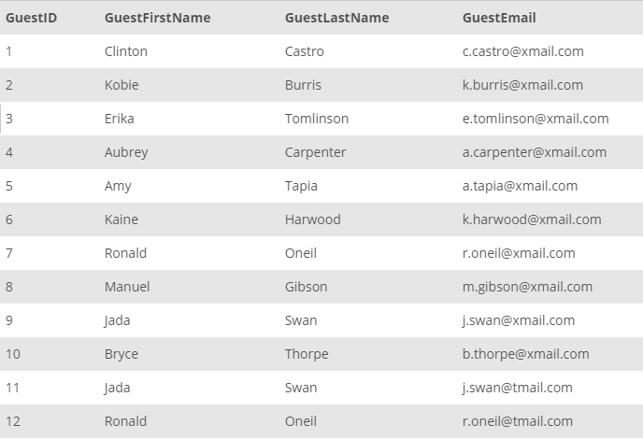

**7/ Create a table name CHANNEL**

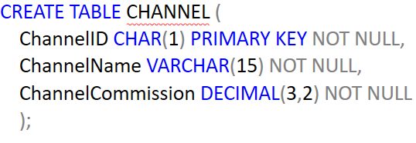

**8/** **Perform inserting values to the CHANNEL table.** [values are provided in the exercise assignment on AsULearn]

As a large platform, InstantStay hosts multiple channels with different commission rates. The channels related information is collected in the CHANNEL table:

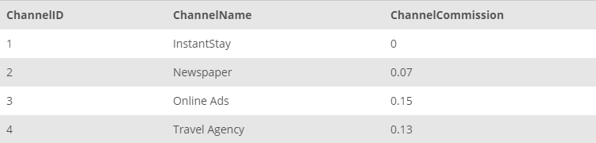

Finally, each reservation in the system is collected in STAY table. Reservations are collected with the corresponding house, guest and channel, start date, and end date. The price information with discount are also tracked in this table. Negative prices indicate the cancellations and the required repayments.

**9/ Create a table name STAY**

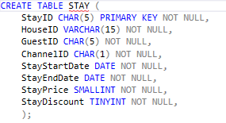

**10/ Perform inserting values to the STAY table**. [values are provided in the exercise assignment on AsULearn]

Collected data for reservations are as follows:

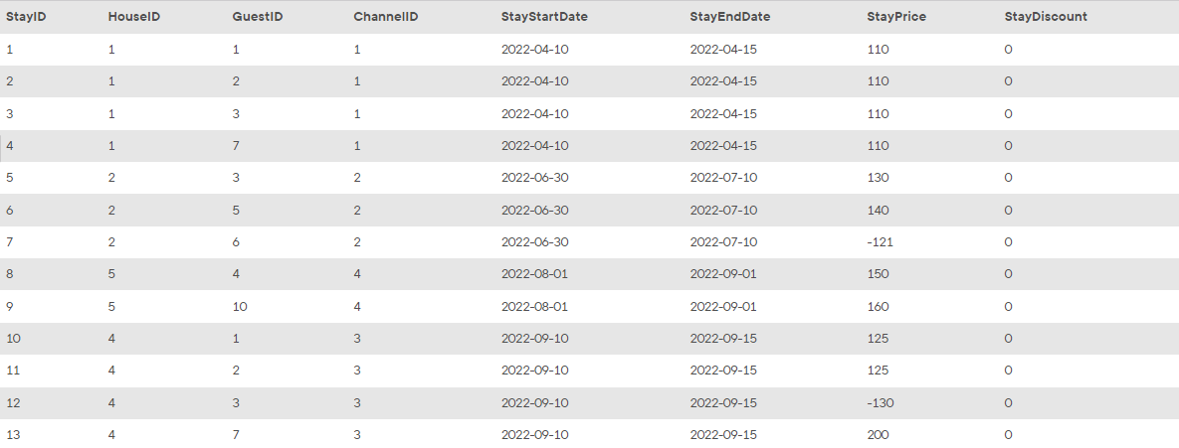

You are assigned as the database administrator to collect and manage transactional data of the InstantStay operations. Your main task is to create SQL scripts to help other teams in InstantStay to retrieve the required data. In the following tasks, you will collect the requested data to help other teams be successful on their business operations.

Make sure you put SQL syntax code below each task inquiry:

**11/ The InstantStay House Development team works on the houses and the coverage of InstantStay over the world. They require a detailed analysis on the count of houses in the InstantStay. To start with, they require the count of houses based in each state in a descending order:**

SELECT House.HouseState, COUNT(HouseID)

FROM HOUSE

GROUP BY HouseState

ORDER BY COUNT(HouseID) DESC;

**12/ House Development team wants the same information (as mentioned in the Task 1) along with the city, state level details:**SELECT HOUSE.HouseState, HOUSE.HouseCity, COUNT(HouseID)

FROM HOUSE

GROUP BY HouseState, HouseCity

ORDER BY COUNT(HouseID) DESC;

**13/ The House Development team considers that having a limited availability of houses in a state could be risky and less beneficial for the business. For Example, The InstantStay will be unable to process the reservation requests if the request count is higher than count of registered houses in the state currently available to rent out. Therefore to take further steps to work on such issues, the team requires to know all the states having less than 2 properties registered in the system:**

SELECT COUNT(HouseID), HouseState

FROM HOUSE

GROUP BY HouseState

HAVING COUNT(HouseID) < 2

ORDER BY COUNT(HouseID) DESC;

**14/ The House Development team also requires to calculate the total number of rooms available in each state?**

SELECT HouseState, SUM(HouseNumberofRooms) AS TotalAvailability

FROM HOUSE

GROUP BY HouseState;

**15/ House Development team wants to know the largest and average house in terms of number of rooms for each state.**

SELECT HOUSE.HouseState,

MAX(HouseNumberofRooms) AS LargestHouse,

AVG(HouseNumberofRooms) AS AverageHouse

FROM HOUSE

GROUP BY HouseState;

***What to turn in***

After you complete this assignment, please use the Word doc included in this assignment, put SQL syntax code answer for each task and turn in:

1. A SQL script file (.sql) containing all the necessary SQL commands solving required tasks
2. A properly prepared & named Word Doc (*.docx).

Rename the Word doc as your **LastName-FirstNameinitial.docx**

Make sure you name your file as “**LastName_FirstNaminitial –SSMS Exercise #1**” and upload on AsUlearn to earn ***20 points.***